Name : amira mohamed sayed Mahmoud

B.N: 23

Date : 12June , 2021

Topic: artificial intelligence

https://github.com/AmiraShafy/artificial-intelligence

Screenshots :

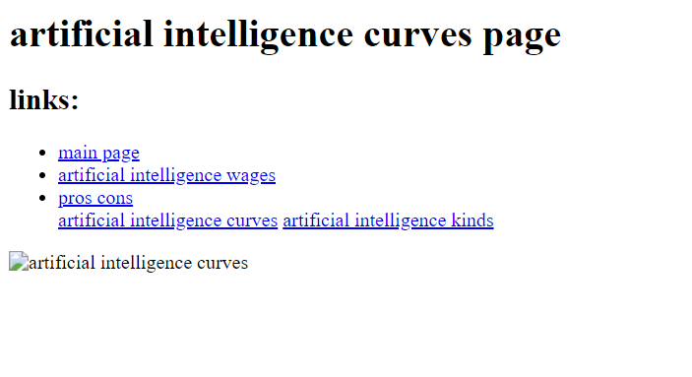

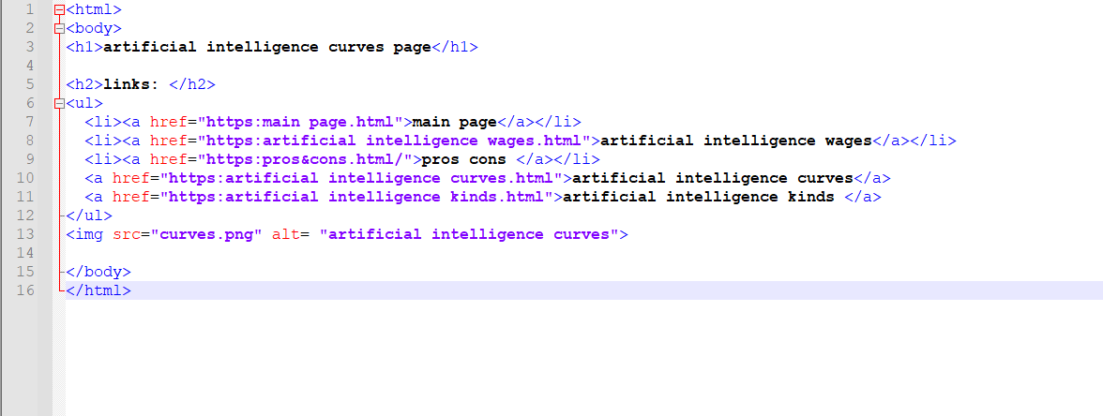

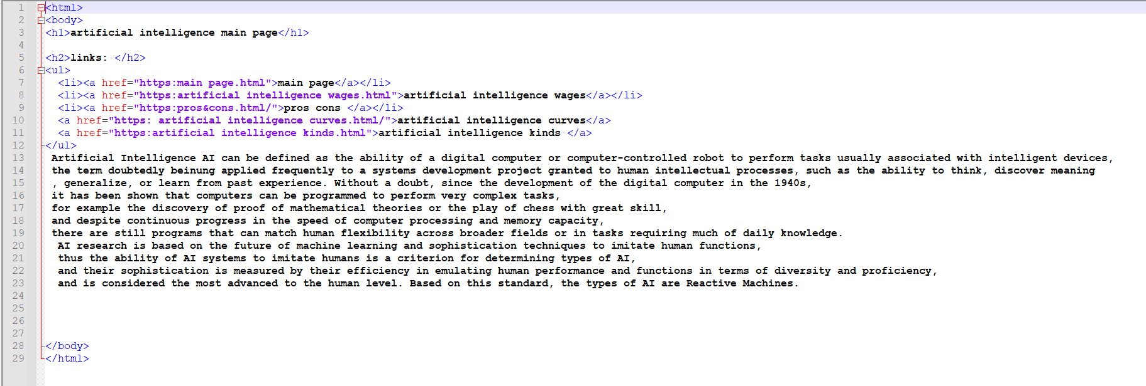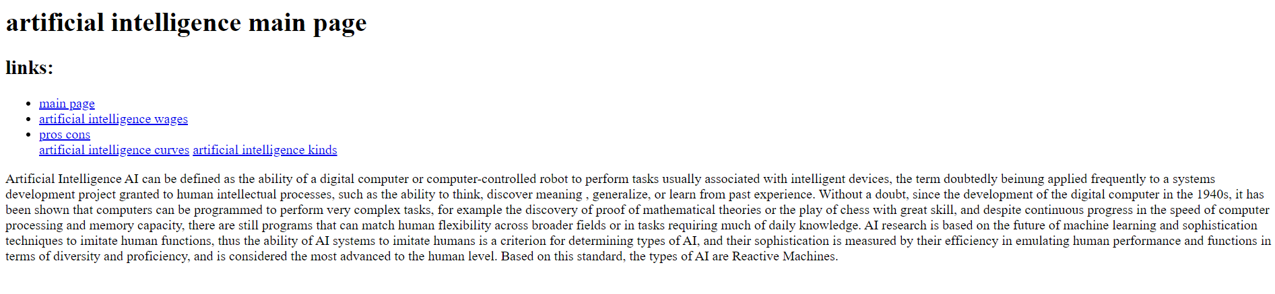source code :

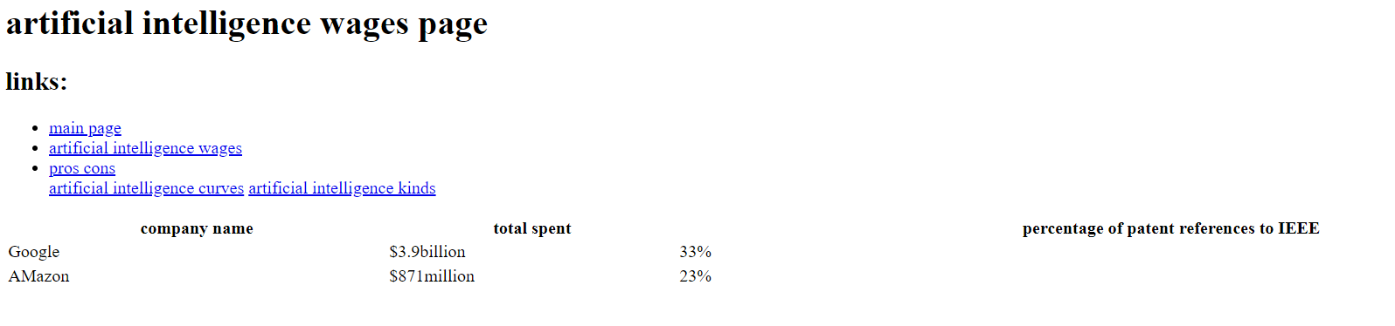

source code :

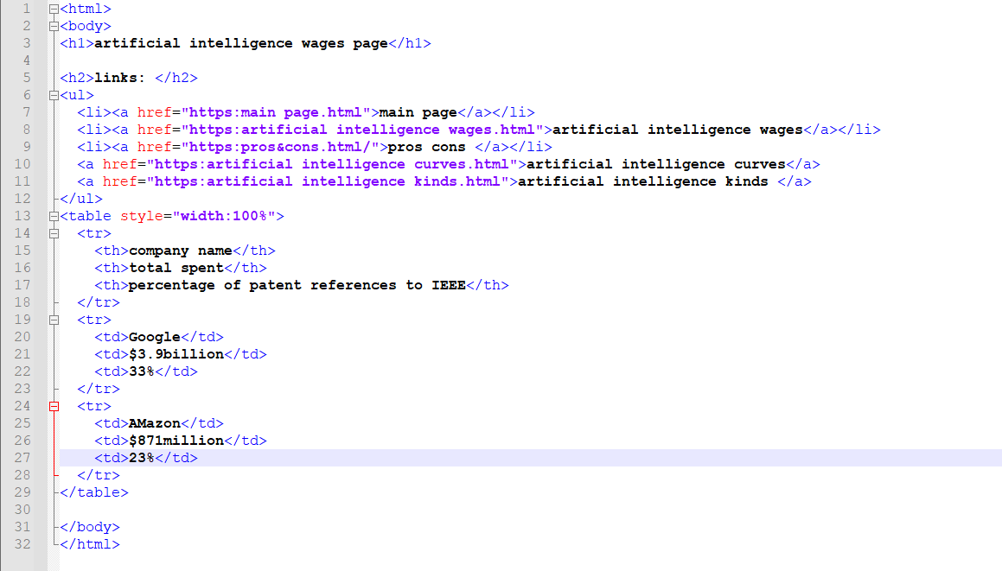

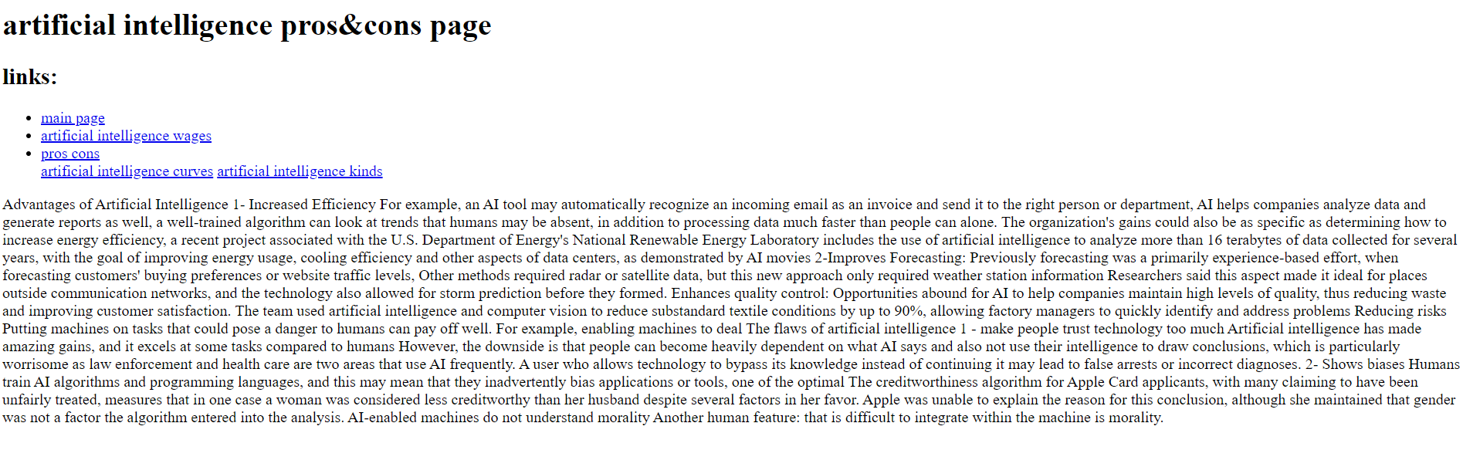

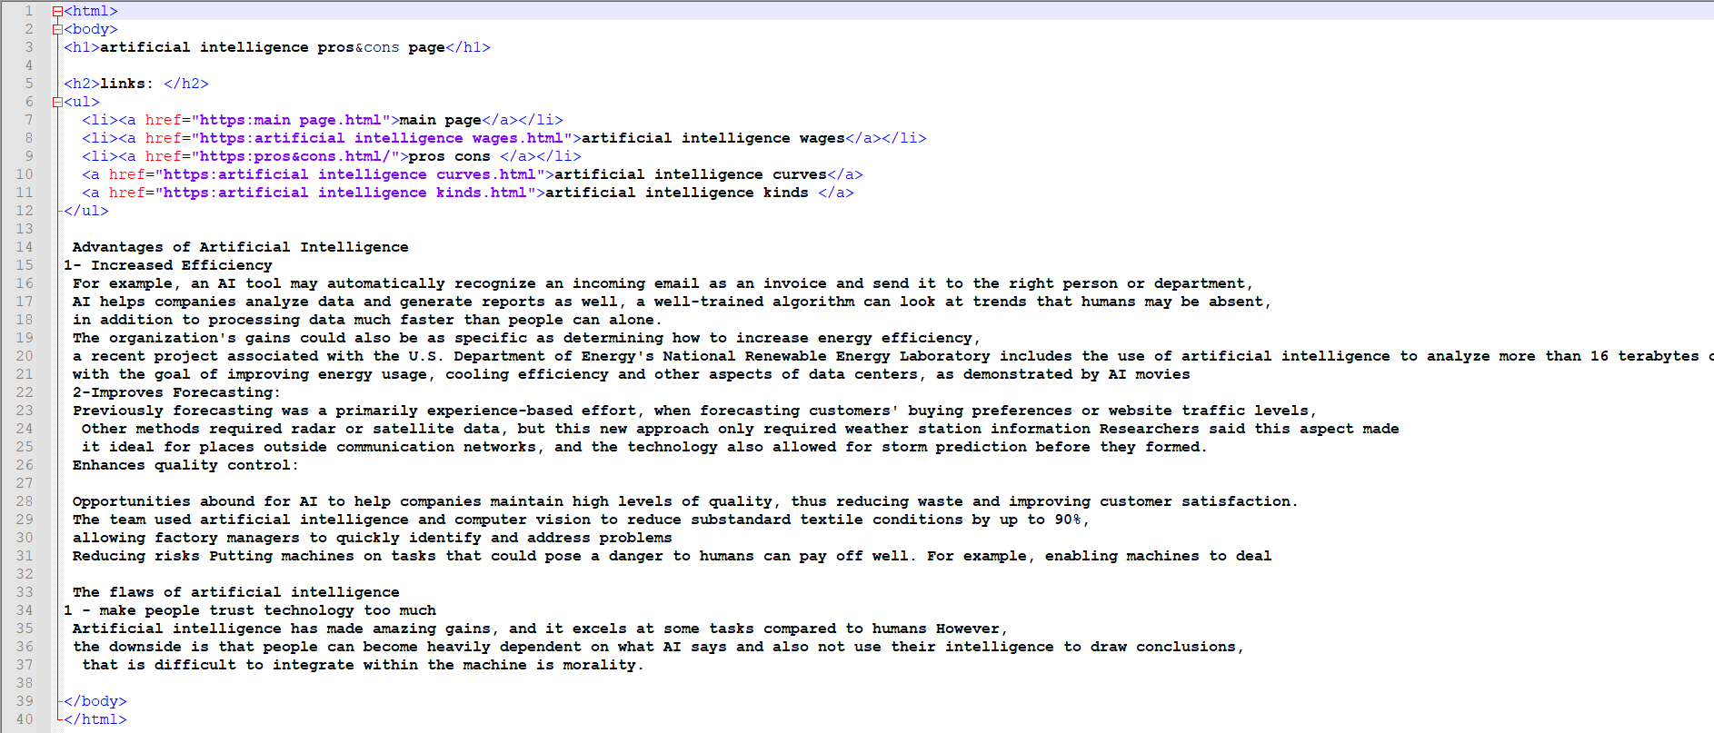Source code :

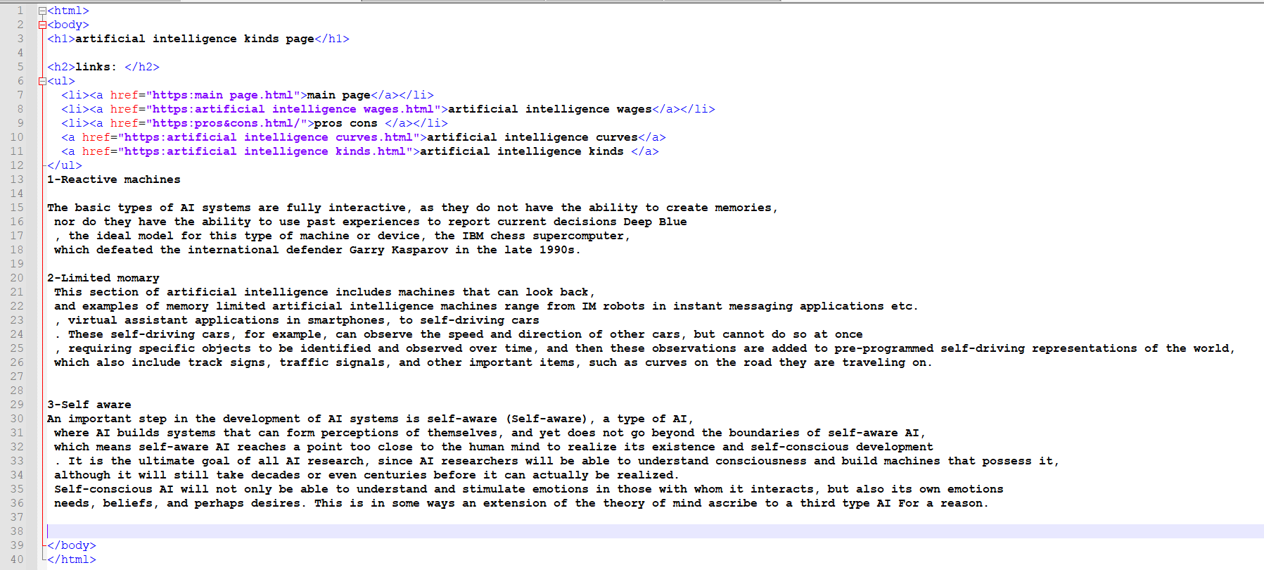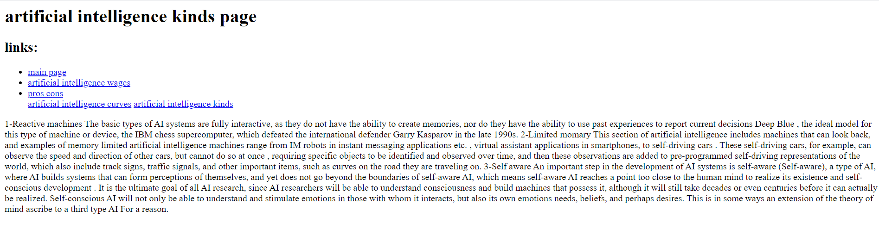source code :